Exercise 1: Mocking and Stubbing

Source Code

ExternalApi.java
public class ExternalApi {
public String getData() {
return "Real Data";
}
}

MyService.java
public class MyService {
private ExternalApi api;
public MyService(ExternalApi api) {
this.api = api;
}
public String fetchData() {
return api.getData();
}
}

MyServiceTest.java
import static org.junit.Assert.assertEquals;
import static org.mockito.Mockito.*;
import org.junit.Test;
public class MyServiceTest {
@Test
public void testExternalApi() {
// Create mock object
ExternalApi mockApi = mock(ExternalApi.class);
// Stub the method
when(mockApi.getData()).thenReturn("Mock Data");
// Inject mock object
MyService service = new MyService(mockApi);
// Execute method
String result = service.fetchData();
// Verify output
assertEquals("Mock Data", result);
}
}

Output
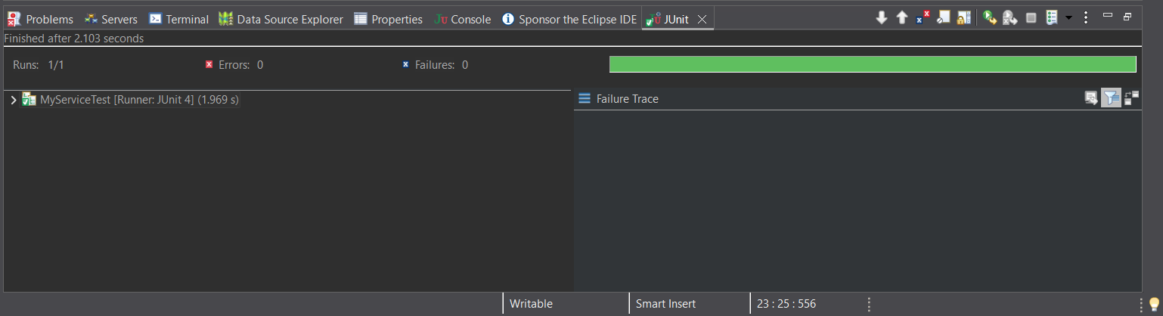

Result
The Mockito framework successfully created a mock object for the external API. The getData() method was stubbed to return the predefined value “Mock Data”. The service fetched the mocked data correctly, and the JUnit test executed successfully with zero errors and zero failures.

Exercise 2: Verifying Interactions

InteractionTest.java
import static org.mockito.Mockito.*;
import org.junit.Test;
public class InteractionTest {
@Test
public void testVerifyInteraction() {
// Create mock object
ExternalApi mockApi = mock(ExternalApi.class);
// Create service object
MyService service = new MyService(mockApi);
// Call the method
service.fetchData();
// Verify interaction
verify(mockApi).getData();
}
}

Output

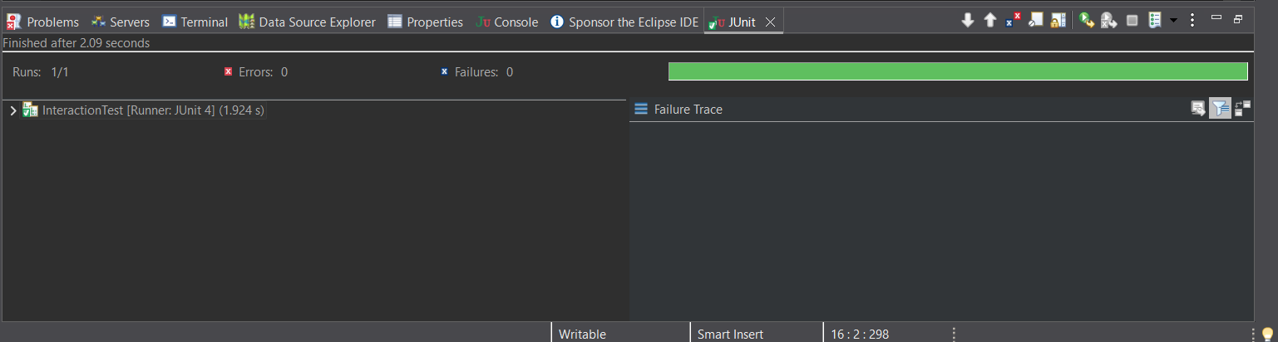

Result
The interaction between the service and the mocked external API was verified successfully using Mockito’s verify() method. The test confirmed that the getData() method was invoked during execution. The test completed successfully with zero errors and zero failures.

